Федеральное государственное образовательное бюджетное

учреждение высшего образования

«Финансовый университет при Правительстве Российской Федерации»

(Финансовый университет)

Колледж информатики и программирования

ОТЧЕТ О ВЫПОЛНЕНИИ ЗАДАНИЯ № 7

Тема: «Калькулятор».

Студент:

Хардова Ангелина Валерьевна

Группа:

3ПКС-420

Преподаватель:

Сибирев Иван Валерьевич Альшакова Елена Леонидовна

Дата: 04.12.2022

Москва 2022г

#### Цель работы:

Разработать калькулятор на языке С#. В проекте использовать прием создания одного обработчика для нескольких событий.

Цель работы:

Фрагмент проекта

Код программы cs:

Код программы xaml:

#### Фрагмент проекта

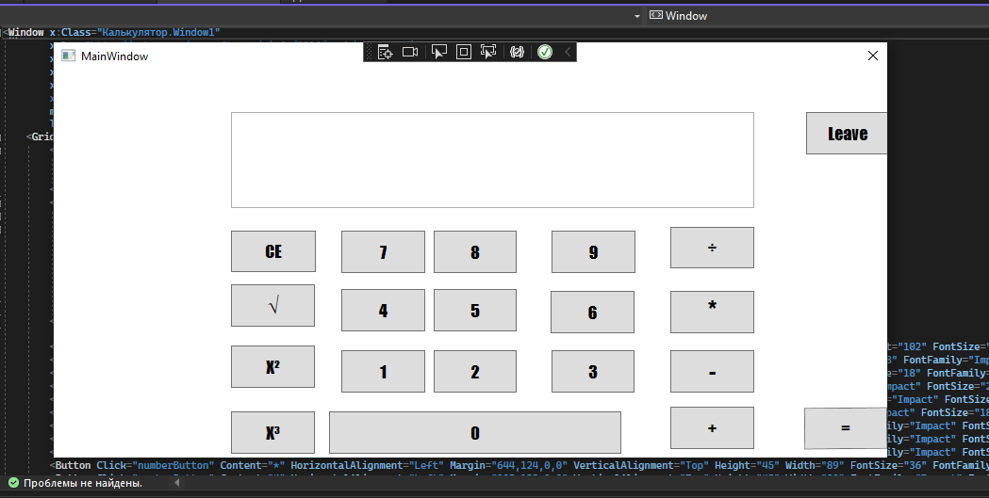

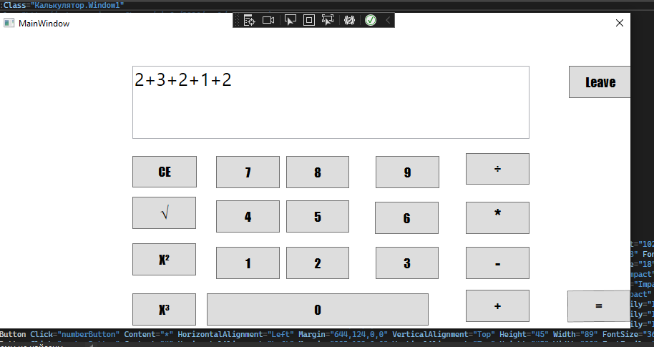

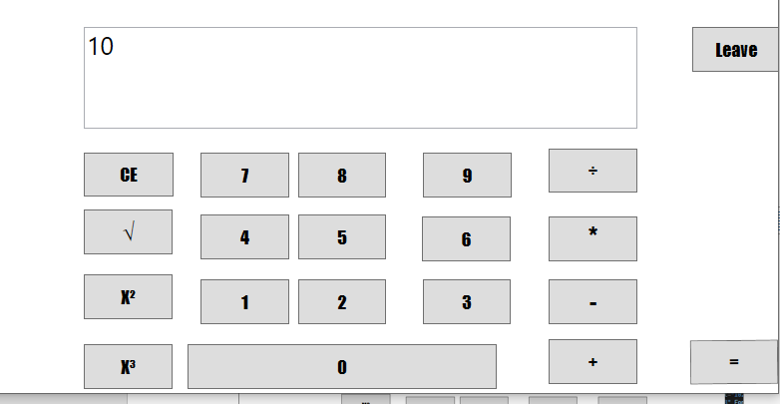

#### Код программы cs:

using System;

using System.Data;

using System.Windows;

using System.Windows.Controls;

namespace Калькулятор

{

public partial class Window1 : Window

{

public Window1()

{

InitializeComponent();

}

private void erasing(object sender, RoutedEventArgs e)

{

if (display.Text == "")

{

MessageBox.Show("Нет данных");

}

display.Clear();

}

private void koren(object sender, RoutedEventArgs e)

{

int numberFromDisplay;

bool isSuccess = int.TryParse(display.Text, out numberFromDisplay);

if (isSuccess)

{

display.Text = Math.Sqrt(numberFromDisplay).ToString();

}

}

private void kvadrat(object sender, RoutedEventArgs e)

{

int numberFromDisplay;

bool isSuccess = int.TryParse(display.Text, out numberFromDisplay);

if (isSuccess)

{

display.Text = Math.Pow(numberFromDisplay, 2).ToString();

}

}

private void kub(object sender, RoutedEventArgs e)

{

int numberFromDisplay;

bool isSuccess = int.TryParse(display.Text, out numberFromDisplay);

if (isSuccess)

{

display.Text = Math.Pow(numberFromDisplay, 3).ToString();

}

}

private void numberButton(object sender, RoutedEventArgs e)

{

var button = sender as Button;

display.Text += button.Content;

}

private void equals(object sender, RoutedEventArgs e)

{

var exp = display.Text.Replace("╳", "*").Replace("÷", "/");

var result = new DataTable().Compute(exp, null);

display.Text = result.ToString();

}

private void exit(object sender, RoutedEventArgs e)

{

this.Close();

}

}

}

#### Код программы xaml:

<Window x:Class="Калькулятор.Window1"

xmlns="http://schemas.microsoft.com/winfx/2006/xaml/presentation"

xmlns:x="http://schemas.microsoft.com/winfx/2006/xaml"

xmlns:d="http://schemas.microsoft.com/expression/blend/2008"

xmlns:mc="http://schemas.openxmlformats.org/markup-compatibility/2006"

xmlns:local="clr-namespace:Калькулятор"

mc:Ignorable="d"

Title="MainWindow" Height="450" Width="900" ResizeMode="NoResize">

<Grid Margin="10,0,0,-16">

<Grid.RowDefinitions>

<RowDefinition Height="112*"/>

<RowDefinition Height="323*"/>

</Grid.RowDefinitions>

<Image Source="/Image3.png" Stretch="Fill" Margin="78,8,21,11" RenderTransformOrigin="0.5,0.5" Grid.RowSpan="2">

<Image.RenderTransform>

<TransformGroup>

<ScaleTransform/>

<SkewTransform/>

<RotateTransform Angle="-1.11"/>

<TranslateTransform/>

</TransformGroup>

</Image.RenderTransform>

</Image>

<TextBox x:Name="display" HorizontalAlignment="Left" Margin="178,44,0,0" TextWrapping="Wrap" Text="" VerticalAlignment="Top" Width="555" Height="102" FontSize="25" Grid.RowSpan="2"/>

<Button Click="erasing" Content="CE" HorizontalAlignment="Left" Margin="178,60,0,0" VerticalAlignment="Top" Height="44" Width="90" FontSize="18" FontFamily="Impact" Grid.Row="1"/>

<Button Click="numberButton" Content="÷" HorizontalAlignment="Left" Margin="644,56,0,0" VerticalAlignment="Top" Height="44" Width="89" FontSize="18" FontFamily="Impact" Grid.Row="1"/>

<Button Click="koren" Content="√" HorizontalAlignment="Left" Margin="178,117,0,0" VerticalAlignment="Top" Height="45" Width="89" FontFamily="Impact" FontSize="22" Grid.Row="1"/>

<Button Click="kvadrat" Content="Х²" HorizontalAlignment="Left" Margin="178,182,0,0" VerticalAlignment="Top" Height="45" Width="89" FontFamily="Impact" FontSize="18" Grid.Row="1"/>

<Button Click="kub" Content="X³" HorizontalAlignment="Left" Margin="178,252,0,0" VerticalAlignment="Top" Height="45" Width="89" FontFamily="Impact" FontSize="18" Grid.Row="1"/>

<Button Click="numberButton" Content="7" HorizontalAlignment="Left" Margin="295,60,0,0" VerticalAlignment="Top" Height="45" Width="89" FontFamily="Impact" FontSize="18" Grid.Row="1"/>

<Button Click="numberButton" Content="8" HorizontalAlignment="Center" Margin="0,60,0,0" VerticalAlignment="Top" Height="45" Width="88" FontFamily="Impact" FontSize="18" Grid.Row="1"/>

<Button Click="numberButton" Content="9" HorizontalAlignment="Left" Margin="518,60,0,0" VerticalAlignment="Top" Height="45" Width="89" FontFamily="Impact" FontSize="18" Grid.Row="1"/>

<Button Click="numberButton" Content="*" HorizontalAlignment="Left" Margin="644,124,0,0" VerticalAlignment="Top" Height="45" Width="89" FontSize="36" FontFamily="Impact" Grid.Row="1"/>

<Button Click="numberButton" Content="4" HorizontalAlignment="Left" Margin="295,122,0,0" VerticalAlignment="Top" Height="45" Width="89" FontFamily="Impact" FontSize="18" Grid.Row="1"/>

<Button Click="numberButton" Content="5" HorizontalAlignment="Center" Margin="0,122,0,0" VerticalAlignment="Top" Height="45" Width="88" FontFamily="Impact" FontSize="18" Grid.Row="1"/>

<Button Click="numberButton" Content="2" HorizontalAlignment="Center" Margin="0,187,0,0" VerticalAlignment="Top" Height="45" Width="88" FontFamily="Impact" FontSize="18" Grid.Row="1"/>

<Button Click="numberButton" Content="1" HorizontalAlignment="Left" Margin="295,187,0,0" VerticalAlignment="Top" Height="45" Width="89" FontFamily="Impact" FontSize="18" Grid.Row="1"/>

<Button Click="numberButton" Content="6" HorizontalAlignment="Left" Margin="517,124,0,0" VerticalAlignment="Top" Height="45" Width="89" FontSize="18" FontFamily="Impact" Grid.Row="1"/>

<Button Click="numberButton" Content="3" HorizontalAlignment="Left" Margin="518,187,0,0" VerticalAlignment="Top" Height="45" Width="88" FontSize="18" FontFamily="Impact" Grid.Row="1"/>

<Button Click="numberButton" Content="-" HorizontalAlignment="Left" Margin="644,187,0,0" VerticalAlignment="Top" Height="45" Width="89" FontSize="24" FontFamily="Impact" Grid.Row="1"/>

<Button Click="numberButton" Content="+" HorizontalAlignment="Left" Margin="644,247,0,0" VerticalAlignment="Top" Height="45" Width="89" FontSize="18" FontFamily="Impact" Grid.Row="1"/>

<Button Click="equals" Content="=" HorizontalAlignment="Left" Margin="786,248,0,0" VerticalAlignment="Top" Height="44" Width="88" FontSize="18" FontFamily="Impact" RenderTransformOrigin="0.5,0.5" Grid.Row="1">

<Button.RenderTransform>

<TransformGroup>

<ScaleTransform/>

<SkewTransform/>

<RotateTransform Angle="-0.507"/>

<TranslateTransform/>

</TransformGroup>

</Button.RenderTransform>

</Button>

<Button Click="numberButton" Content="0" HorizontalAlignment="Center" Margin="0,252,0,0" VerticalAlignment="Top" Height="45" Width="310" FontFamily="Impact" FontSize="18" Grid.Row="1"/>

<Button Click="exit" Content="Leave" HorizontalAlignment="Left" Margin="788,44,0,0" VerticalAlignment="Top" Height="45" Width="89" FontFamily="Impact" FontSize="18"/>

<Image Height="100" Width="100" RenderTransformOrigin="-3.12,1.606" Margin="-374,72,1164,162" Grid.Row="1"/>

</Grid>

</Window>